Oracle Homework Chapter 6: Aggregate functions

For each of the following queries, label the columns and format the numerical and date types as shown.
Include the following comments at the top:
-- Your Name
-- Date
Put all of the queries in one script, and do not zip the file.

- Display the job, highest, lowest, and total salary for each job type. Also display the number of people for each job type.
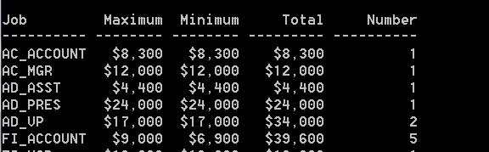
Etc.

- Write a query that will display the difference between the highest and lowest salary for all of the departments. Exclude any departments where the difference is zero.
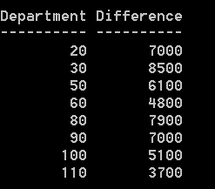

- Display the manager number and salary of the lowest paid employee for that manager. Exclude anyone whose manager is not known (NULL). Exclude any groups where the minimum salary is less than $1000. Sort the output in descending order of salary, as shown below:
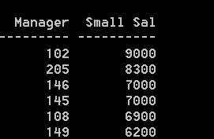
Etc.

- (Northwoods database) Show the section days and how many classes meet on those days. The results are shown below:

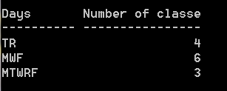

- Display the number of classes by days, and time of the day, formatted as shown below:

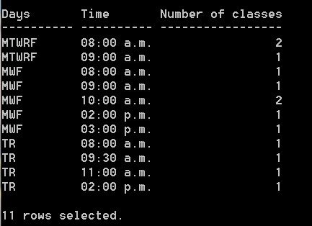

- Now replace the day expression with a more meaningful explanation, and order by days. Remove leading zeroes from the time, as shown below:

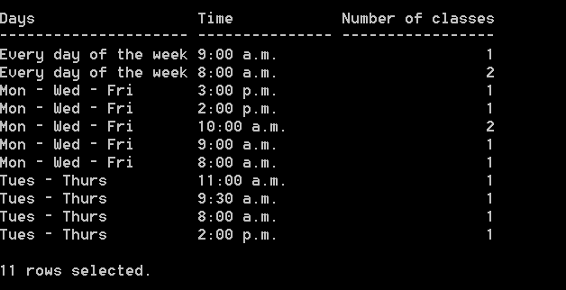

- Using the Animal Shelter schema, create a new problem using the features introduced in this chapter.

